University of Technology, Jamaica

Faculty of Engineering and Computing

School of Computing and Information Technology (SCIT)

Module Name: Introduction to Human Computer Interaction

Module Code: 3023

Tutor: Nadine Maitland

.

Authors:

Jade Robinson -1701077

Michael Jones -1604149

Andre Cameron -1701496

Due Date: March 2, 2021

**UCD Approach**: This User Centered Design abstract prototype for our proposed UTech Online 4.0 system.

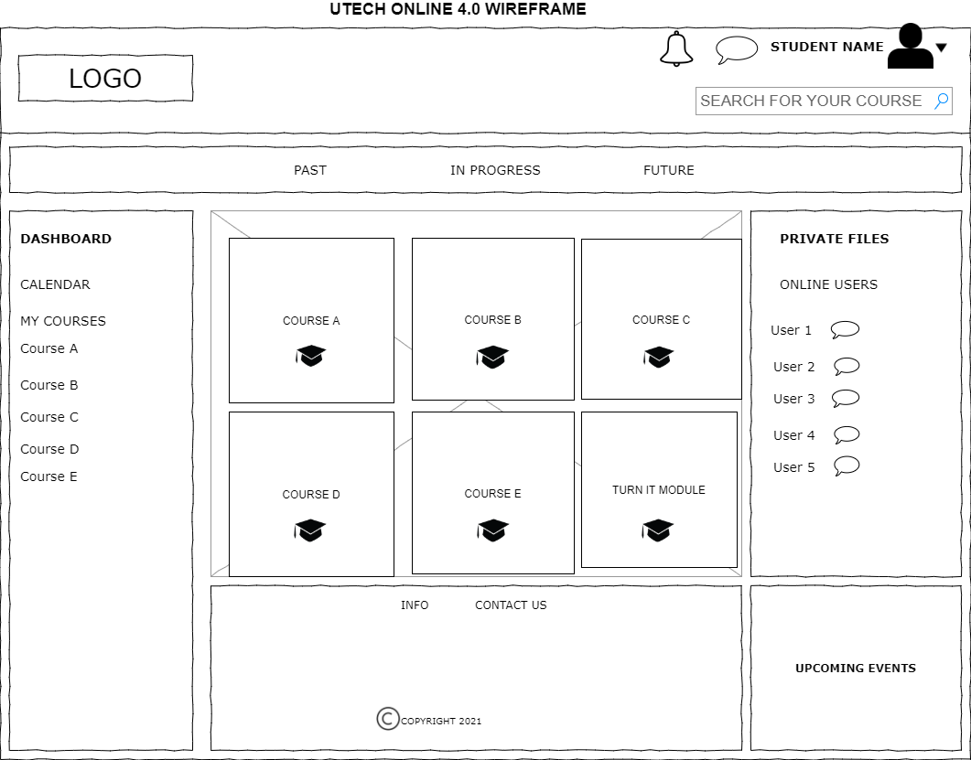

Describe how your essential use cases are enacted by acting on these interfaces. This will expose any missing information or functionality

